**LAB # 2**

**Good practices of programming**

**OBJECTIVE**

Implementing good code practices and code optimization techniques.

**Lab Task1 :**

Create a design for the mark sheet by taking runtime value of student name, total marks, obtained marks and calculate its percentage, grade and GPA. Use good practices of programming that we have studied and ensure that the outcomes should be presented in a proper Viewable approach.

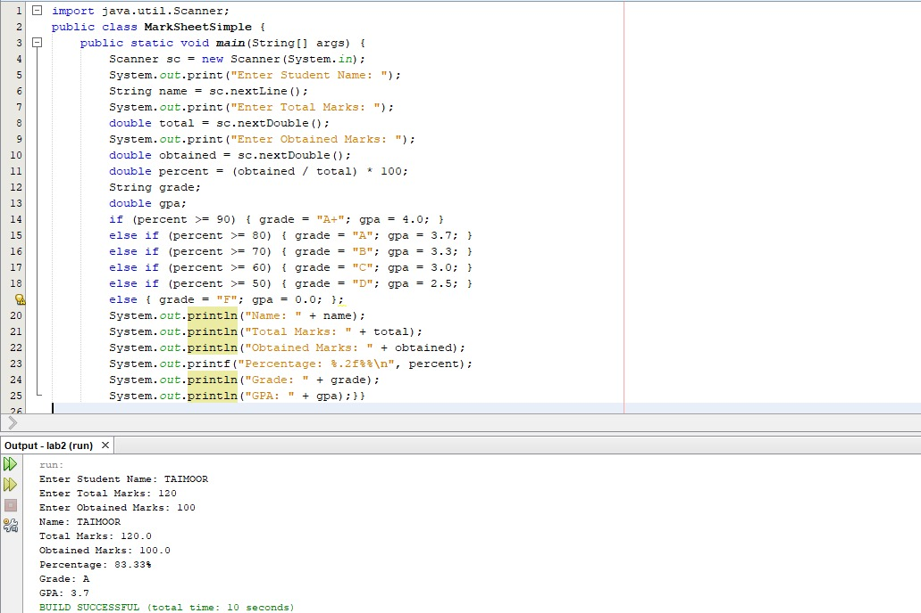

**Lab Task1 :**

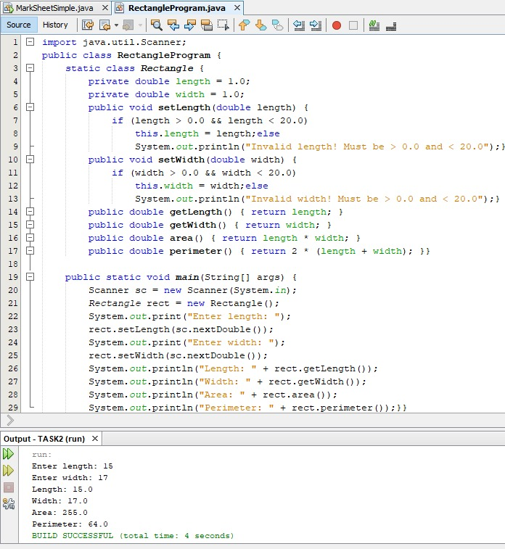

**GITHUB UPLOAD:**